**《Python程序设计》**

**课程项目作业报告**



**序号及名称：**项目作业2-三种数列求和的多种方法

**学号与姓名：3240103494 郑雨静**

**年级与专业：**大一 工商管理

**学 院 (系)：**求是学院

**日期：**2025年4月23日

# 一、作品名称：《库：等差数列求和》

## 数列描述：

相邻两项之差为[常数](https://baike.baidu.com/item/%E5%B8%B8%E6%95%B0/2215683?fromModule=lemma_inlink" \t "https://baike.baidu.com/item/%E7%AD%89%E5%B7%AE%E6%95%B0%E5%88%97/_blank)的[数列](https://baike.baidu.com/item/%E6%95%B0%E5%88%97/731531?fromModule=lemma_inlink" \t "https://baike.baidu.com/item/%E7%AD%89%E5%B7%AE%E6%95%B0%E5%88%97/_blank)。

## 代码对应的Python知识点：

方法一：自定义函数 类

方法二：定循环与不定循环

方法三：函数sum求和

## 源码及注释：

方法一：自定义函数 类

# 定义计算等差数列的前n项和的函数

class CalculateSum:

def __init__(self):

# 输入首项

self.a1 = float(input("请输入等差数列的首项a："))

# 输入公差

self.d = float(input("请输入等差数列的公差d："))

# 输入项数

self.n = int(input("请输入要求和的项数n："))

def sum_dengcha(self):

# 根据等差数列的通项公式计算尾项

an = self.a1 + (self.n - 1) * self.d

# 使用求和公式计算前n项和

sum_value = self.n * (self.a1 + an) / 2

return sum_value

# 调用函数并输出结果

obj = CalculateSum()

result = sum_dengcha()

print(f"等差数列前n项和为: {result}")

方法二：定循环与不定循环

#用定循环for实现

# 输入首项

a1 = float(input("请输入等差数列的首项a："))

# 输入公差

d = float(input("请输入等差数列的公差d："))

# 输入项数

n = int(input("请输入要求和的项数n："))

sum_value=0

#用通项公式计算数列的第i项并累加求和

for i in range(1,n+1):

sum_value = sum_value + a1 + d*(i-1)

print(f"等差数列前n项和为: {sum_value}")

#用不定循环while实现

# 输入首项

a1 = float(input("请输入等差数列的首项a："))

# 输入公差

d = float(input("请输入等差数列的公差d："))

# 输入项数

n = int(input("请输入要求和的项数n："))

sum_value=0

i=1

#用通项公式计算数列的第i项并用判定循环累加求和

while i<=n:

sum_value = sum_value + a1 + d*(n-1)

i+=1

print(f"等差数列前n项和为: {sum_value}")

方法二：用自定义函数实现

class CalculateSum:

def __init__(self,n):

self.n=n

def sum(self):

s=0

term=''

for i in range(1,self.n+1):

term+=str(i)

s+=int(term)

return(s)

n=int(input('请输入要求和的项数n:'))

seq=CalculateSum(n)

print('数列和为%s'%seq.sum())

方法三：用类来实现

N=int(input('请输入要求和的项数n:'))

def calculate_sum(n):

#与定循环结合

sequence_sum=0

term=''

for i in range(n):

term+=str(i)

sequence_sum+=int(term)

return sequence_sum

print('数列和为%s'%calculate_sum(N))

**代码测试（GUI包装）**

import tkinter as tk

from tkinter import scrolledtext, Radiobutton

import inspect

# #用定循环for实现

def sum_by_loop(n):

# n=int(input('请输入要求和的项数n:'))

sequence_sum=0

term=''

for i in range(1,n+1):

term+=str(i)

sequence_sum+=int(term)

# print('数列和为%s'%sequence_sum)

return sequence_sum

#用不定循环while实现

def sum_by_while(n):

# n=int(input('请输入要求和的项数n:'))

sequence_sum=0

term=''

i=1

while i<=n:

term+=str(i)

sequence_sum+=int(term)

i+=1

# print('数列和为%s'%sequence_sum)

return sequence_sum

# 用自定义函数来实现

def sum_by_custom(n):

def calculate_sum(n):

#与定循环结合

sequence_sum=0

term=''

for i in range(1,n+1):

term+=str(i)

sequence_sum+=int(term)

return sequence_sum

# print('数列和为%s'%calculate_sum(N))

return calculate_sum(n)

#用类来实现

def sum_by_class_method(n):

class CalculateSum:

def __init__(self,n):

self.n=n

def sum(self):

s=0

term=''

for i in range(1,self.n+1):

term+=str(i)

s+=int(term)

return(s)

# n=int(input('请输入要求和的项数n:'))

seq=CalculateSum(n)

# print('数列和为%s'%seq.sum())

return seq.sum()

root = tk.Tk()

root.title("数列求和库")

root.geometry('800x700') # 调整大小以确保所有元素适应

root.configure(bg='#f7f7f7')

# a_label = tk.Label(root, text="输入a：", bg='#f7f7f7', font=('Arial', 12))

# a_label.pack()

# a_entry = tk.Entry(root, width=50)

# a_entry.pack(pady=5)

n_label = tk.Label(root, text="输入n：", bg='#f7f7f7', font=('Arial', 12))

n_label.pack()

n_entry = tk.Entry(root, width=50)

n_entry.pack(pady=5)

method_label = tk.Label(root, text="选择求和方法：", bg='#f7f7f7', font=('Arial', 12))

method_label.pack()

methods = {

'定循环求和': sum_by_loop,

'不定循环求和': sum_by_while,

'自定义函数求和': sum_by_custom,

'类方法求和': sum_by_class_method

}

method_var = tk.StringVar()

method_var.set('定循环求和')

for text in methods.keys():

Radiobutton(root, text=text, variable=method_var, value=text, bg='#f7f7f7', font=('Arial', 10)).pack(anchor=tk.W)

result_label = tk.Label(root, text="", font=('Helvetica', 12), bg='#f7f7f7')

result_label.pack(pady=20)

code_label = tk.Label(root, text="源代码：", bg='#f7f7f7', font=('Arial', 12))

code_label.pack()

code_text = scrolledtext.ScrolledText(root, width=90, height=15, bg='white')

code_text.pack(pady=5)

def calculate_and_display():

# a = a_entry.get()

n = n_entry.get()

try:

n = int(n)

assert n > 0

except (ValueError, AssertionError):

result_label.config(text="n需要是正整数")

return

# if not a.isdigit():

# result_label.config(text="a需要是数字")

# return

method = method_var.get()

result = methods[method](n)

result_label.config(text=f"求和结果: {result}")

code_text.delete('1.0', tk.END)

code_text.insert(tk.INSERT, inspect.getsource(methods[method]))

calculate_button = tk.Button(root, text="计算", command=calculate_and_display, bg='#b3b3b3', font=('Arial', 12))

calculate_button.pack(pady=10)

exit_button = tk.Button(root, text="退出", command=root.quit, bg='#b3b3b3', font=('Arial', 12), width=10)

exit_button.pack(side=tk.BOTTOM, pady=10)

root.mainloop()

1. Spider

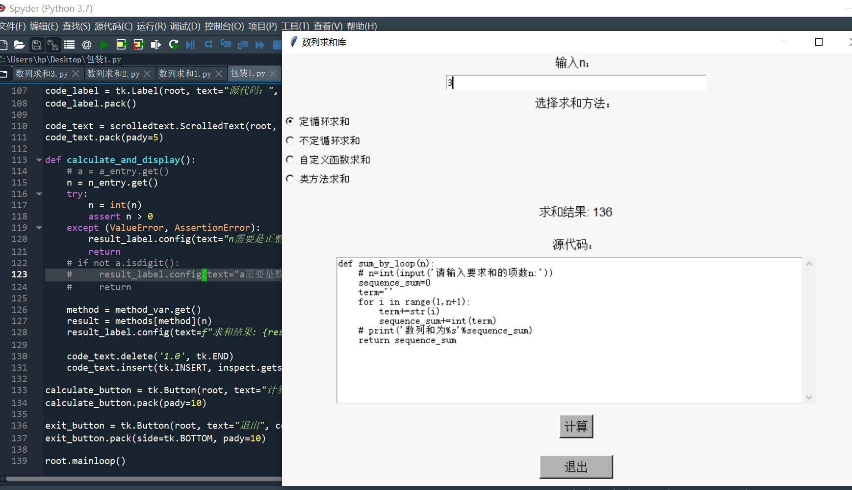

1. Thonny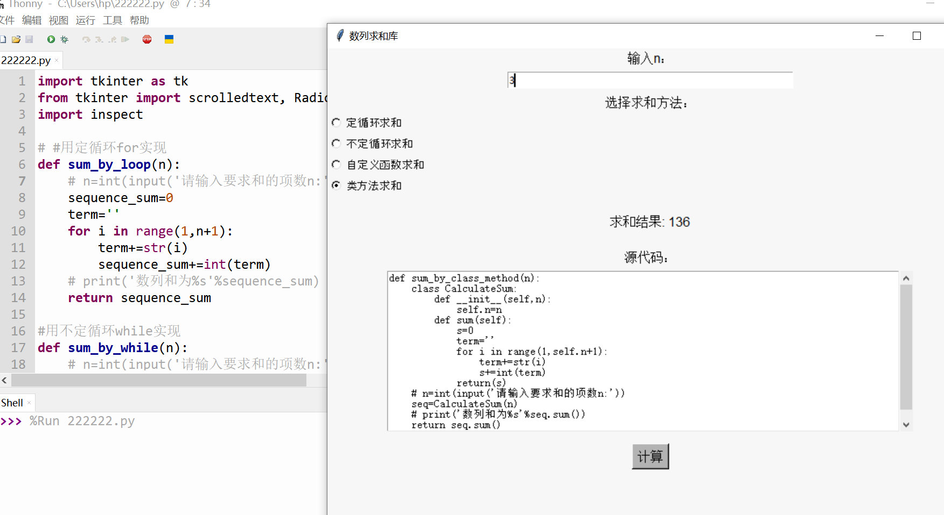
2. IDLE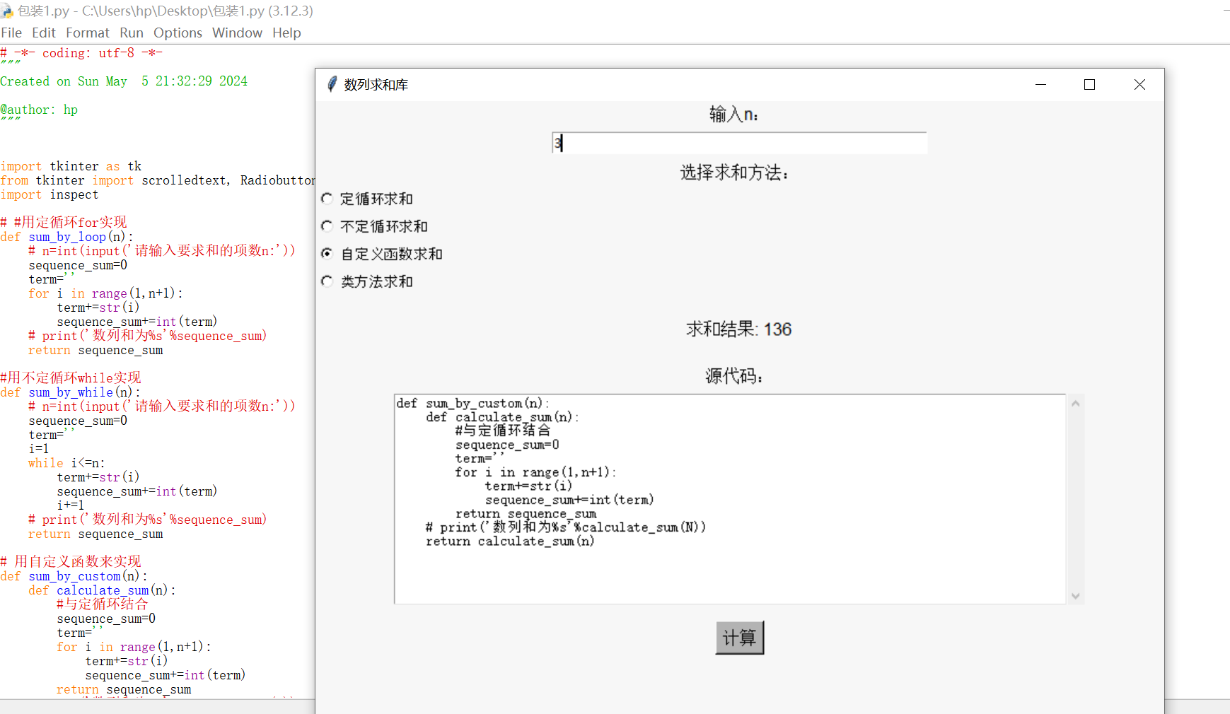

# 二、作品名称：《数列求和库2.0》，难度****

## 数列描述：任意等比数列

## 代码对应的Python知识点：

方法一：定循环与不定循环

方法二：函数 自定义

方法三：类

**源码注释**

方法一：定循环与不定循环

a1=int(input('请输入等比数列首项：'))

q=float(input('请输入等比数列公比：'))

n=int(input('请输入等比数列项数：'))

sequence_sum=a1

for i in range(n-1):

a1*=q

sequence_sum+=a1

print("该等比数列前%s项和为%.2f"%(n,sequence_sum))

a1=int(input('请输入等比数列首项：'))

q=float(input('请输入等比数列公比：'))

n=int(input('请输入等比数列项数：'))

sequence_sum=a1

i=1

while i<n:

a1*=q

sequence_sum+=a1

i+=1

print("该等比数列前%s项和为%.2f"%(n,sequence_sum))

方法二：自定义函数

# 自定义函数结合定循环实现

def sum_of_GeometricSeries(a1,q,n):

sequence_sum=a1

for i in range(n-1):

a1*=q

sequence_sum+=a1

return sequence_sum

terms=input('请输入等比数列首项、公比和项数，用空格隔开：')

lst=list(map(float,terms.split()))

lst[2]=int(lst[2])

print("该等比数列前%s项和为%.2f"%(lst[2],sum_of_GeometricSeries(lst[0],lst[1],lst[2])))

方法三：类

#用类来实现

class GeometricSeries:

def __init__(self,first_term,common_ratio,num_of_term):

self.a1=first_term

self.q=common_ratio

self.n=num_of_term

def calcu_sum(self):

sequence_sum=self.a1

for i in range(self.n-1):

self.a1*=self.q

sequence_sum+=self.a1

return sequence_sum

terms=input('请输入等比数列首项、公比和项数，用空格隔开：')

lst=list(map(float,terms.split()))

series=GeometricSeries(lst[0],lst[1],int(lst[2]))

print("该等比数列前%s项和为%.2f"%(int(lst[2]),series.calcu_sum()))

**代码测试（用GUI包装）**

import tkinter as tk

from tkinter import scrolledtext, Radiobutton

import inspect

# #用定循环for实现

def sum_by_loop(a1,q,n):

# n=int(input('请输入要求和的项数n:'))

sequence_sum=a1

for i in range(n-1):

a1*=q

sequence_sum+=a1

# print('数列和为%s'%sequence_sum)

return sequence_sum

#用不定循环while实现

def sum_by_while(a1,q,n):

# n=int(input('请输入要求和的项数n:'))

sequence_sum=a1

i=1

while i<n:

a1*=q

sequence_sum+=a1

i+=1

return sequence_sum

# 用自定义函数来实现

def sum_by_custom(a1,q,n):

def sum_of_GeometricSeries(a1,q,n):

sequence_sum=a1

for i in range(n-1):

a1*=q

sequence_sum+=a1

return sequence_sum

# print('数列和为%s'%calculate_sum(N))

return sum_of_GeometricSeries(a1,q,n)

#用类来实现

def sum_by_class_method(a1,q,n):

class GeometricSeries:

def __init__(self,first_term,common_ratio,num_of_term):

self.a1=first_term

self.q=common_ratio

self.n=num_of_term

def calcu_sum(self):

sequence_sum=self.a1

for i in range(self.n-1):

self.a1*=self.q

sequence_sum+=self.a1

return sequence_sum

# n=int(input('请输入要求和的项数n:'))

# print('数列和为%s'%seq.sum())

series=GeometricSeries(a1,q,n)

return series.calcu_sum()

def calcu_sum(self):

sequence_sum=self.a1

for i in range(self.n-1):

self.a1*=self.q

sequence_sum+=self.a1

return sequence_sum

# n=int(input('请输入要求和的项数n:'))

# print('数列和为%s'%seq.sum())

series=GeometricSeries(a1,q,n)

return series.calcu_sum()

root = tk.Tk()

root.title("数列求和库")

root.geometry('800x700') # 调整大小以确保所有元素适应

root.configure(bg='#f7f7f7')

a_label = tk.Label(root, text="输入a1：", bg='#f7f7f7', font=('Arial', 12))

a_label.pack()

a_entry = tk.Entry(root, width=50)

a_entry.pack(pady=5)

q_label = tk.Label(root, text="输入q：", bg='#f7f7f7', font=('Arial', 12))

q_label.pack()

q_entry = tk.Entry(root, width=50)

q_entry.pack(pady=5)

n_label = tk.Label(root, text="输入n：", bg='#f7f7f7', font=('Arial', 12))

n_label.pack()

n_entry = tk.Entry(root, width=50)

n_entry.pack(pady=5)

method_label = tk.Label(root, text="选择求和方法：", bg='#f7f7f7', font=('Arial', 12))

method_label.pack()

methods = {

'定循环求和': sum_by_loop,

'不定循环求和': sum_by_while,

'自定义函数求和': sum_by_custom,

'类方法求和': sum_by_class_method

}

method_var = tk.StringVar()

method_var.set('定循环求和')

for text in methods.keys():

Radiobutton(root, text=text, variable=method_var, value=text, bg='#f7f7f7', font=('Arial', 10)).pack(anchor=tk.W)

result_label = tk.Label(root, text="", font=('Helvetica', 12), bg='#f7f7f7')

result_label.pack(pady=20)

code_label = tk.Label(root, text="源代码：", bg='#f7f7f7', font=('Arial', 12))

code_label.pack()

code_text = scrolledtext.ScrolledText(root, width=90, height=15, bg='white')

code_text.pack(pady=5)

def calculate_and_display():

a1 = a_entry.get()

q=q_entry.get()

n = n_entry.get()

try:

n = int(n)

a1=float(a1)

q=float(q)

assert n > 0

except (ValueError, AssertionError):

result_label.config(text="n需要是正整数")

return

# if not a.isdigit():

# result_label.config(text="a需要是数字")

# return

method = method_var.get()

result = methods[method](a1,q,n)

result_label.config(text=f"求和结果: {result}")

code_text.delete('1.0', tk.END)

code_text.insert(tk.INSERT, inspect.getsource(methods[method]))

calculate_button = tk.Button(root, text="计算", command=calculate_and_display, bg='#b3b3b3', font=('Arial', 12))

calculate_button.pack(pady=10)

exit_button = tk.Button(root, text="退出", command=root.quit, bg='#b3b3b3', font=('Arial', 12), width=10)

exit_button.pack(side=tk.BOTTOM, pady=10)

root.mainloop()

1.spyder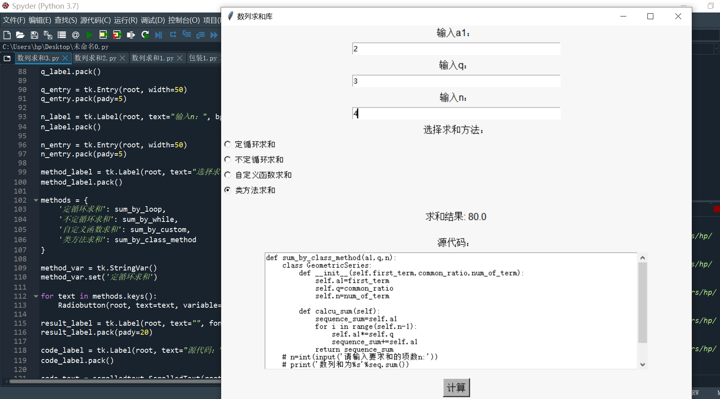

2.Thonny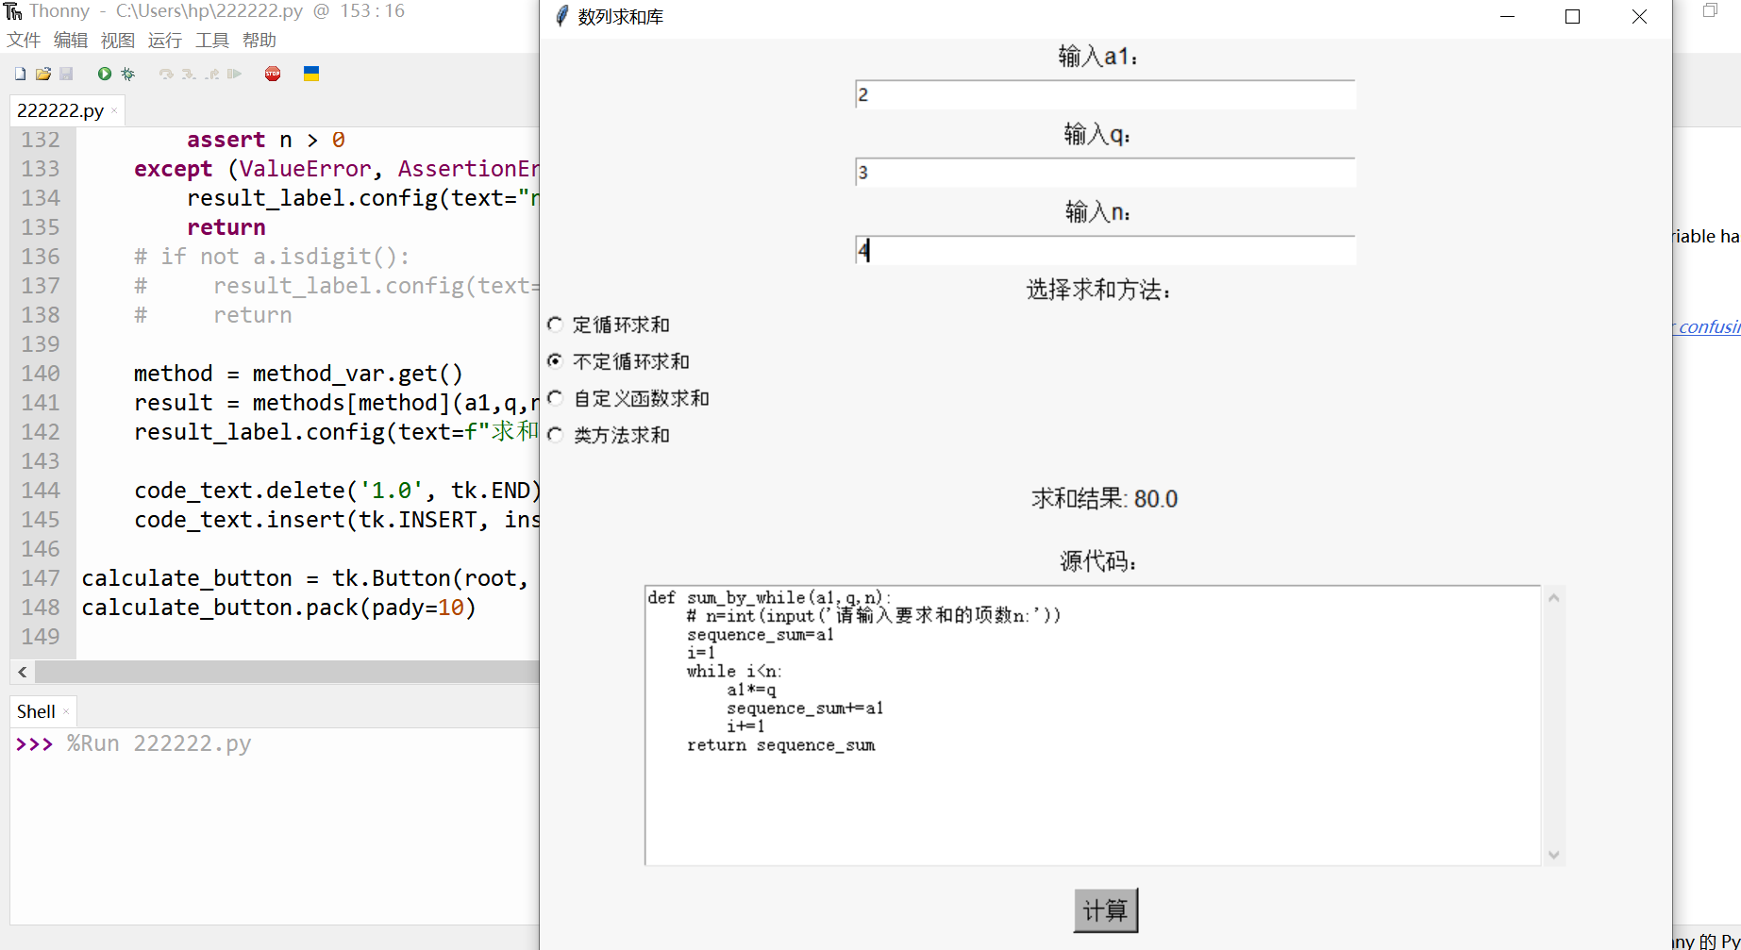

3.IDLE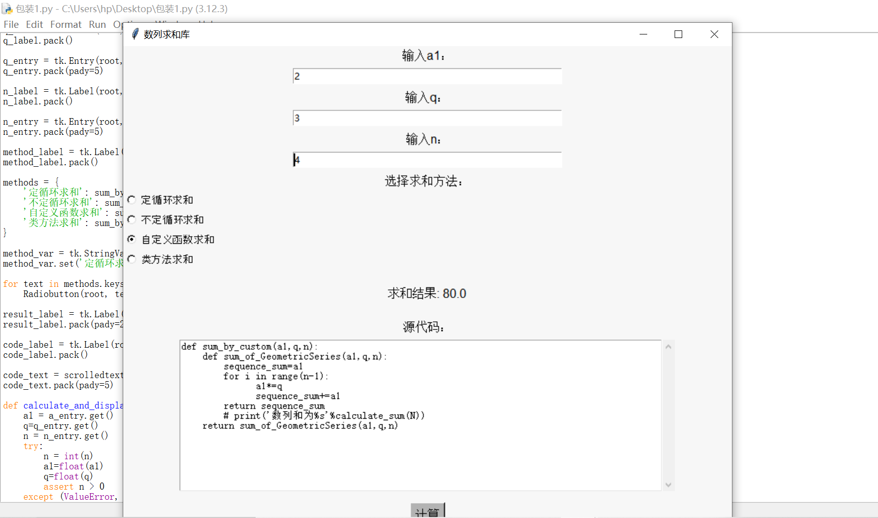

# 三、作品名称：《数列求和库3.0》，难度*****

## 数列描述：斐波那契数列

## 代码对应的Python知识点：

方法一：定循环与不定循环

方法二：函数 自定义，递归

方法三：类

**源码注释**

方法一：定循环与不定循环

n=int(input("请输入项数："))

a=1;b=1;seq_sum=1

for i in range(1,n):

seq_sum+=b

b+=a

a=b-a

print("斐波那契数列前%d项和为%s"%(n,seq_sum))

# 不定循环实现

n=int(input("请输入项数："))

a=1;b=1;seq_sum=1;i=1

while i<n:

seq_sum+=b

b+=a

a=b-a

i+=1

print("斐波那契数列前%d项和为%s"%(n,seq_sum))

方法二.自定义函数与递归

# 自定义函数结合递归算法实现

def FibonacciNumber(n):

if n==0 or n==1:

return 1

else:

return FibonacciNumber(n-1)+FibonacciNumber(n-2)

n=int(input("请输入项数："))

seq_sum=0

for i in range(n):

seq_sum+=FibonacciNumber(i)

print("斐波那契数列前%d项和为%s"%(n,seq_sum))

方法三.类

#用类实现

class FibonacciNumber:

def __init__(self,n):

self.n=n

def sequence_creation(self):

sequence=[1,1]

if self.n==1:

return [1]

for i in range(2,self.n):

sequence.append(sequence[i-1]+sequence[i-2])

return sequence

n=int(input("请输入项数："))

seq=FibonacciNumber(n)

print("斐波那契数列前%d项和为%s"%(n,sum(seq.sequence_creation())))

**代码测试（用GUI包装）**

import tkinter as tk

from tkinter import scrolledtext, Radiobutton

import inspect

# #用定循环for实现

def sum_by_loop(n):

a=1;b=1;seq_sum=1

for i in range(1,n):

seq_sum+=b

b+=a

a=b-a

return seq_sum

#用不定循环while实现

def sum_by_while(n):

a=1;b=1;seq_sum=1;i=1

while i<n:

seq_sum+=b

b+=a

a=b-a

i+=1

return seq_sum

# 用自定义函数来实现

def sum_by_custom(n):

def FibonacciNumber(n):

if n==0 or n==1:

return 1

else:

return FibonacciNumber(n-1)+FibonacciNumber(n-2)

seq_sum=0

for i in range(n):

seq_sum+=FibonacciNumber(i)

return seq_sum

#用类来实现

def sum_by_class_method(n):

class FibonacciNumber:

def __init__(self,n):

self.n=n

def sequence_creation(self):

sequence=[1,1]

if self.n==1:

return [1]

for i in range(2,self.n):

sequence.append(sequence[i-1]+sequence[i-2])

return sequence

seq=FibonacciNumber(n)

return sum(seq.sequence_creation())

def sequence_creation(self):

sequence=[1,1]

if self.n==1:

return [1]

for i in range(2,self.n):

sequence.append(sequence[i-1]+sequence[i-2])

return sequence

seq=FibonacciNumber(n)

return sum(seq.sequence_creation())

root = tk.Tk()

root.title("数列求和库")

root.geometry('800x700') # 调整大小以确保所有元素适应

root.configure(bg='#f7f7f7')

n_label = tk.Label(root, text="输入n：", bg='#f7f7f7', font=('Arial', 12))

n_label.pack()

n_entry = tk.Entry(root, width=50)

n_entry.pack(pady=5)

method_label = tk.Label(root, text="选择求和方法：", bg='#f7f7f7', font=('Arial', 12))

method_label.pack()

methods = {

'定循环求和': sum_by_loop,

'不定循环求和': sum_by_while,

'自定义函数求和': sum_by_custom,

'类方法求和': sum_by_class_method

}

method_var = tk.StringVar()

method_var.set('定循环求和')

for text in methods.keys():

Radiobutton(root, text=text, variable=method_var, value=text, bg='#f7f7f7', font=('Arial', 10)).pack(anchor=tk.W)

result_label = tk.Label(root, text="", font=('Helvetica', 12), bg='#f7f7f7')

result_label.pack(pady=20)

code_label = tk.Label(root, text="源代码：", bg='#f7f7f7', font=('Arial', 12))

code_label.pack()

code_text = scrolledtext.ScrolledText(root, width=90, height=15, bg='white')

code_text.pack(pady=5)

def calculate_and_display():

# a = a_entry.get()

n = n_entry.get()

try:

n = int(n)

assert n > 0

except (ValueError, AssertionError):

result_label.config(text="n需要是正整数")

return

# if not a.isdigit():

# result_label.config(text="a需要是数字")

# return

method = method_var.get()

result = methods[method](n)

result_label.config(text=f"求和结果: {result}")

code_text.delete('1.0', tk.END)

code_text.insert(tk.INSERT, inspect.getsource(methods[method]))

calculate_button = tk.Button(root, text="计算", command=calculate_and_display, bg='#b3b3b3', font=('Arial', 12))

calculate_button.pack(pady=10)

exit_button = tk.Button(root, text="退出", command=root.quit, bg='#b3b3b3', font=('Arial', 12), width=10)

exit_button.pack(side=tk.BOTTOM, pady=10)

root.mainloop()

1.spyder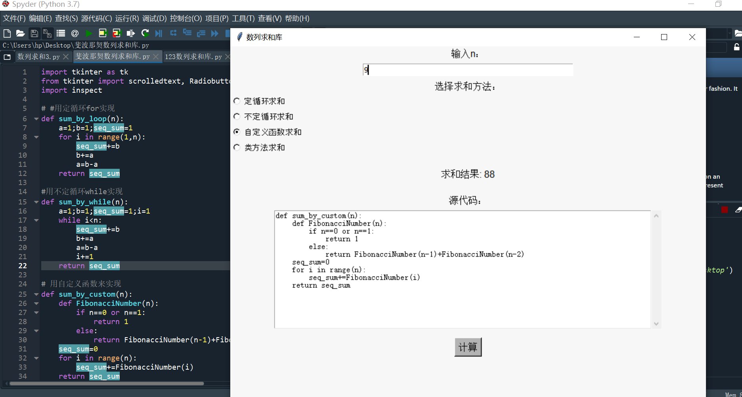

2.Thonny

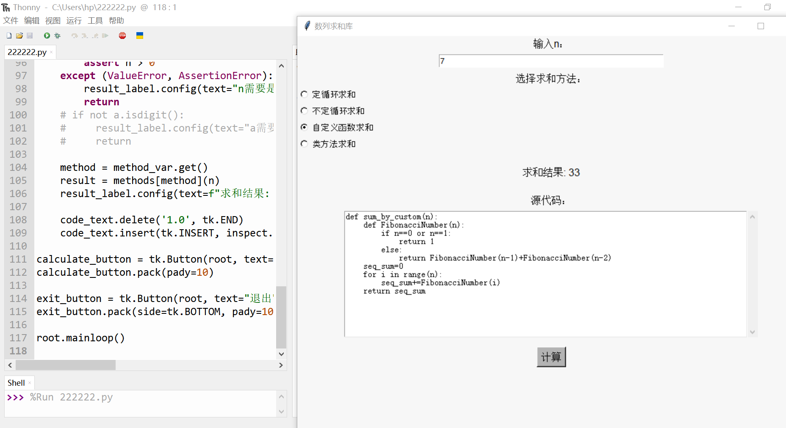

3.IDLE